***Draft* Planning Proposal**

**LOCAL GOVERNMENT AREA: Wollongong City Council**

**NAME OF DRAFT LEP: Shone Avenue and West Dapto Road, Horsley**

**ADDRESS OF LAND: Lot C DP 397366; Lot 5 DP 26069; Lot 19 DP 879647; Lot 102 DP 1137454; Lot 1012 DP 862178; Lot 2 DP 26069; Lot 1 DP 607456; and Lot 1 DP 26069, Horsley.**

**MAP: Location Map**

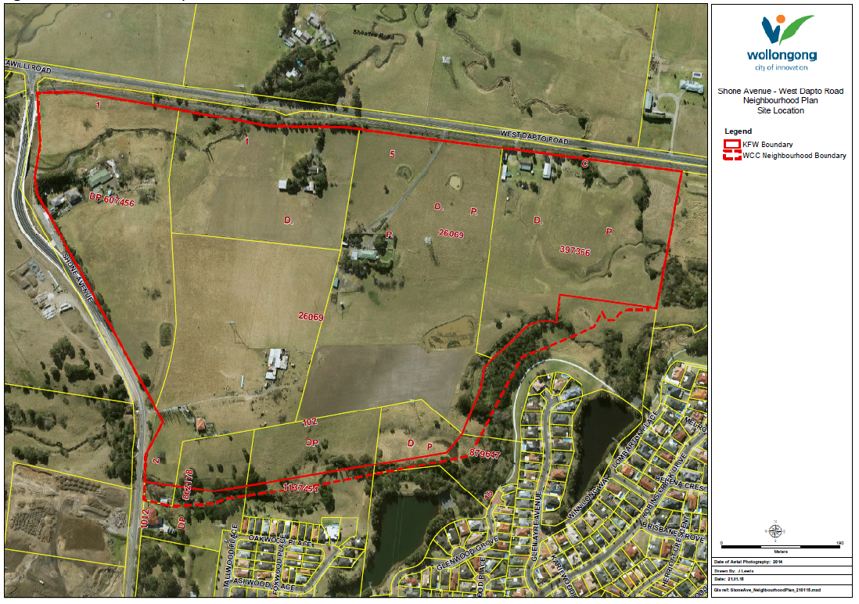

**BACKGROUND:**

As part of the development of the West Dapto Release Area, a draft Neighbourhood Plan has been prepared for land fronting the corner of Shone Avenue and West Dapto Road, Horsley. Council on 23 February 2015 resolved to exhibit the draft Neighbourhood Plan. Council also resolved to prepare a draft Planning Proposal to make minor amendments to the Wollongong Local Environmental Plan 2009, to realign part of the R2 Low Density Residential and E3 Environmental Management zone boundary to reflect updated flood information and facilitate the efficient subdivision of land. Corresponding amendments to the floor space ratio and minimum lot size maps are also required.

**Part 1: OBJECTIVES OR INTENDED OUTCOMES OF THE PLANNING PROPOSAL:**

|  |
| --- |
| **What is the purpose of the Planning Proposal?**  The draft Planning Proposal would facilitate the implementation of a Neighbourhood Plan for Shone Avenue and West Dapto Road, Horsley, realigning part of the R2 Low Density Residential and E3 Environmental Management zone boundary to reflect updated flood information and facilitate the efficient subdivision of land upon receipt of the subdivision application. |

**Part 2: EXPLANATION OF THE PROVISIONS OF THE PLANNING PROPOSAL:**

|  |
| --- |
| **How are the objectives of the Planning Proposal to be achieved? How will the LEP be changed?**  Minor boundary adjustments between E3 Environmental Management and R2 Low Density Residential zones to reflect updated flood information. Corresponding amendments to the minimum lot size and floor space ratio maps.   * Amendment of the Wollongong LEP 2009 Zoning Map in accordance with the proposed zoning map shown as attachment 1, which indicates R2 Low Density Residential zoning for part of the site currently zoned E3 Environmental Management; * Amendment of the Wollongong LEP 2009 Minimum Lot Size Map in accordance with the proposed minimum lot size map shown as attachment 2, which indicates 450m² for areas proposed to be zoned R2 Low Density Residential; and * Amendment of the Wollongong LEP 2009 Floor Space Ratio Map in accordance with the proposed floor space ratio map shown as attachment 3, which indicates a maximum permissible floor space ratio of 0.5:1 for areas proposed to be zoned R2 Low Density Residential. |

**Part 3: JUSTIFICATION FOR THE PLANNING PROPOSAL:**

**Section A – Need for the planning proposal**

|  |  |
| --- | --- |
| **1. Is the planning proposal a result of any strategic study or report?** | West Dapto is an urban release area in planning for over 10 years. This planning proposal is consistent with the Council endorsed vision and masterplan that encompasses the subject site and surrounds, which identifies the land for residential development. It is also noted that the West Dapto Urban Release Area is identified as a key area of growth in the Illawarra Regional Strategy.  The planning proposal is considered necessary to facilitate a Neighbourhood Plan within the West Dapto Urban Release Area.  The Planning Proposal is the result of a Council resolution dated 23 February 2015. The report to Council included the recommendations from the following supporting documents:   * Ecological Constraints Analysis (EcoLogical 2014); * Bushfire Constraints Assessment (Australian Bushfire Protection Planners P/L 2014); * Flood Study (KFW Infrastructure 2014) – an update to Council’s Mullet Creek Flood Study 2009; * Preliminary Aboriginal Heritage Assessment Report (AHMS 2014); and * Noise Impact Assessment in relation to the proximity to the rail line (Reverb Acoustics 2014). |
| **2. Is the planning proposal the best means of achieving the objectives or intended outcomes, or is there a better way?** | The Planning Proposal is the only means of achieving the intended outcome. |

**Section B – Relationship to strategic planning framework**

|  |  |
| --- | --- |
| **4. Is the planning proposal consistent with the objectives and actions of the applicable regional or sub-regional strategy (including the Sydney Metropolitan Strategy and exhibited draft strategies)?** | Illawarra Regional Strategy –  West Dapto is an urban release area in planning for over 10 years and identified in the Illawarra Regional Strategy as a key growth area for Wollongong and the Illawarra. The Planning Proposal is consistent with the vision and masterplan that encompasses the subject site and identifies the land for residential development.  Rezoning additional land in accordance with the land constraints and optimising the efficiency of development in the West Dapto Urban Release Area is consistent with the Illawarra Regional Strategy.  The Planning Proposal has considered constraints and sensitivities of the site in line with the sustainability criteria, such as biodiversity and flooding, and is endeavouring to ensure that where possible vegetation is preserved. Proposed development is outside the 1 in 100 year event.  The Planning Proposal is consistent with the draft Illawarra Regional Growth and Infrastructure Plan, which identifies as a priority the maintaining of a strong and sustained increase in housing construction in greenfield areas to overcome low levels of production over the last decade. New release areas in the region are expected to account for 57% of the 45,000 homes required to 2031 – equating to approximately 1,300 new lots per year. A key action of this Growth Plan is the implementation of neighbourhood planning principles in Local Plans, Development Control Plans and other Council based mechanisms. |
| **5. Is the planning proposal consistent with the local council’s Community Strategic Plan or other local strategic plan?** | Wollongong 2022 Community Strategic Plan –  West Dapto is one of the five key aspirations for Wollongong Council in its Delivery Program – this is reflected in the goals and objectives of the Community Strategic Plan.  *Aspiration: Council will work in collaboration with key agencies to provide the infrastructure needed to support growth within the West Dapto Urban release Area. This will include improving access infrastructure and local services which are needed to support the additional 17,000 future housing lots within the release area.* |
| **6. Is the planning proposal consistent with applicable State Environmental Planning Policies?** | Refer to Table A – Checklist of State Environmental Planning Policies. |
| **7. Is the planning proposal consistent with applicable Ministerial Directions (s.117 directions)?** | Refer to Table B – Checklist of Ministerial Directions. |

**Section C – Environmental, social and economic impact**

|  |  |
| --- | --- |
| **8. Is there any likelihood that critical habitat or threatened species, populations or ecological communities, or their habitats, will be adversely affected as a result of the proposal?** | A desktop ecological constraints analysis (EcoLogical 2014) identifies low biodiversity constraints in the Neighbourhood Plan area, including the likely absence of Threatened Ecological Communities. The reports states that, based on previous surveys in the locality by EcoLogical (2013), no threatened flora are considered likely to occur on the subject site.  The report notes that the subject site supports the foraging habitat of the threatened micro chiropteran bat species, including the farm dams and drainage lines. Some stands of planted native trees and scattered isolated native trees (paddock trees) may also support roosting and nesting habitats for fauna species from the locality. A more detailed flora and fauna assessment will be required as part of the development application for subdivision.  Note that Council has resolved that a flora and fauna report be prepared for the areas proposed to be rezoned and exhibited as part of the draft Planning Proposal. |
| **9. Are there any other likely environmental effects as a result of the planning proposal and how are they proposed to be managed?**  *Flooding, Landslip, Bushfire, Flora and Fauna, Contamination, Water Quality etc.*  *If it is necessary to undertake technical studies or investigations to address an identified matter, these should be undertaken following the initial gateway determination. Scope of additional studies should be identified in initial draft PP for endorsement by Gateway.* | Part of the precinct is identified as flood prone due to Robins Creek, which is part of the Mullet Creek catchment. The applicant has submitted a more recent and detailed flood study of the precinct (KFW 2014) as an update to Council’s Mullet Creek Flood Study (2009), Flood Risk Management Plan and Mullet Creek Flood Extension Study (2011). The updated flood study demonstrated that the peak velocity and depth flows associated with the 1% Annual Exceedance Probability (AEP) annual exceedance probability storm event are generally contained within the back of the riparian creek system. Proposed residential lots and detention basins will not be located in the 1 in 100 year extent areas. Note that Council has resolved that further work is required as part of the Gateway determination to demonstrate how any proposed cut and fill of flood affected land could be managed within the Neighbourhood Plan area.  The following documents were submitted in support of the Planning Proposal request:   * Ecological Constraints Analysis (EcoLogical 2014); * Bushfire Constraints Assessment (Australian Bushfire Protection Planners P/L 2014); * Flood Study (KFW Infrastructure 2014) – an update to Council’s Mullet Creek Flood Study 2009; * Preliminary Aboriginal Heritage Assessment Report (AHMS 2014); and * Noise Impact Assessment in relation to the proximity to the rail line (Reverb Acoustics 2014).   Advice will be sought through the Gateway process as to any further studies required. |
| **10, How has the planning proposal adequately addressed any social and economic effects?**  *Include heritage impacts (Aboriginal and European) traffic impacts, urban design considerations and any impact on community infrastructure such as schools, hospitals, or potential economic impacts - retails centres, impacts on CBD, employment lands etc.* | The planning proposal is considered a housekeeping matter because the land is already zoned as part of the West Dapto Urban release Area. It is considered that the impacts of the proposal are minimal on a social and economic basis other than it would permit efficient development of land.  A preliminary Aboriginal Heritage Assessment report (AHMS 2014) has not identified any known Aboriginal sites within the proposed development area, however has identified a number of areas that are considered to have “high” archaeological potential which require further investigation. The report recommends that archaeological testing be undertaken in accordance with the code of practice for archaeological sites, prior to the commencement of any development works on the site. Further, it is likely that additional consultation to allow for a cultural significance assessment will be required as part of this process. |

**Section D – State and Commonwealth interests**

|  |  |
| --- | --- |
| **11. Is there adequate public infrastructure for the planning proposal?** | The precinct is not yet sufficiently serviced by water, sewerage, electricity and communication services. Endeavour Energy has been working with Council and active developers to ensure electricity supply will be available to new dwellings as they are constructed. Sydney Water has developed a Growth Servicing Plan to provide water and wastewater (sewer) services in stages over the next 40 years. The precinct should be serviced by 2015-16 and the work begins this year to service Stages 1 and 2. |
| **12. What are the views of State and Commonwealth public authorities consulted in accordance with the gateway determination?** | The Gateway determination will stipulate the required consultation with public authorities. Consultation has occurred to date in relation to the draft Neighbourhood Plan with the Office of Water; Office of Environment & Heritage, TransGrid, NSW Rural Fire Service, and Sydney Water. |

**PART 4: MAPS, WHERE RELEVANT, TO IDENTIFY THE INTENT OF THE PLANNING PROPOSAL AND THE AREA TO WHICH IT APPLIES**

**Proposed Planning Controls –**changes are proposed to the Zoning Map, Floor Space Ratio Map, and Minimum Lot Size Map.

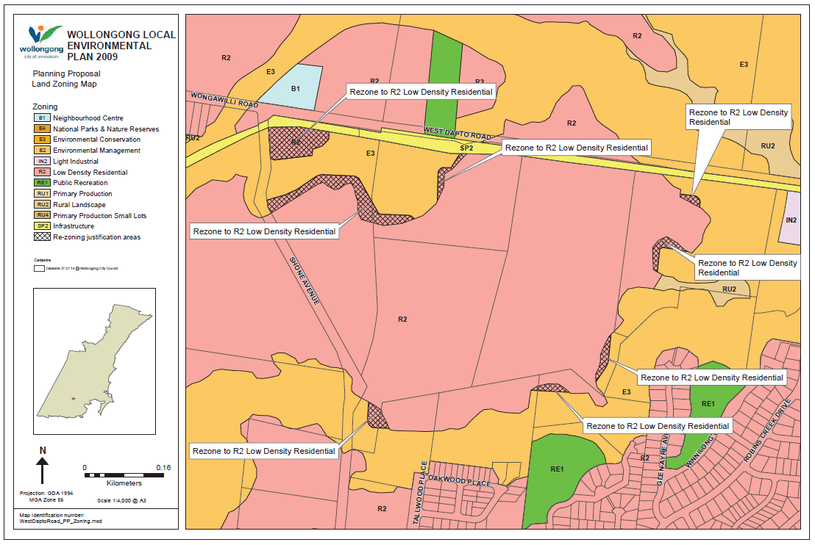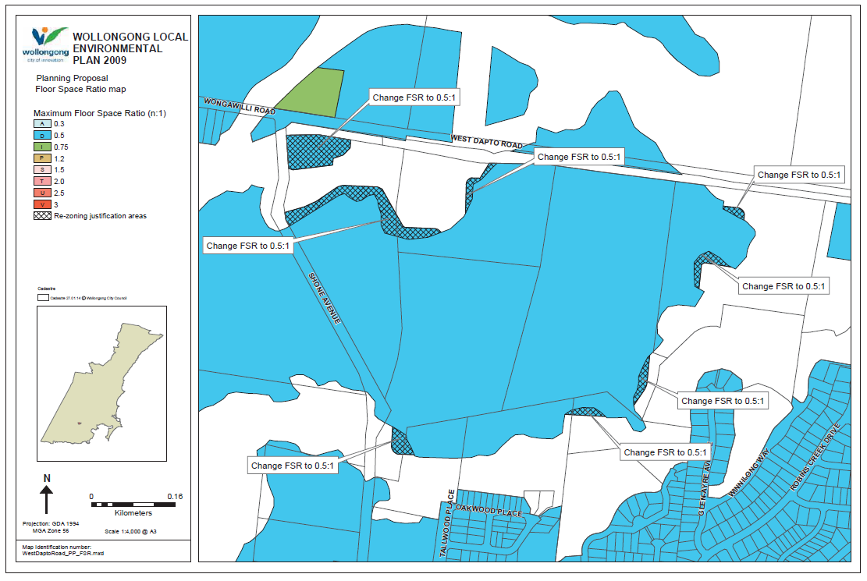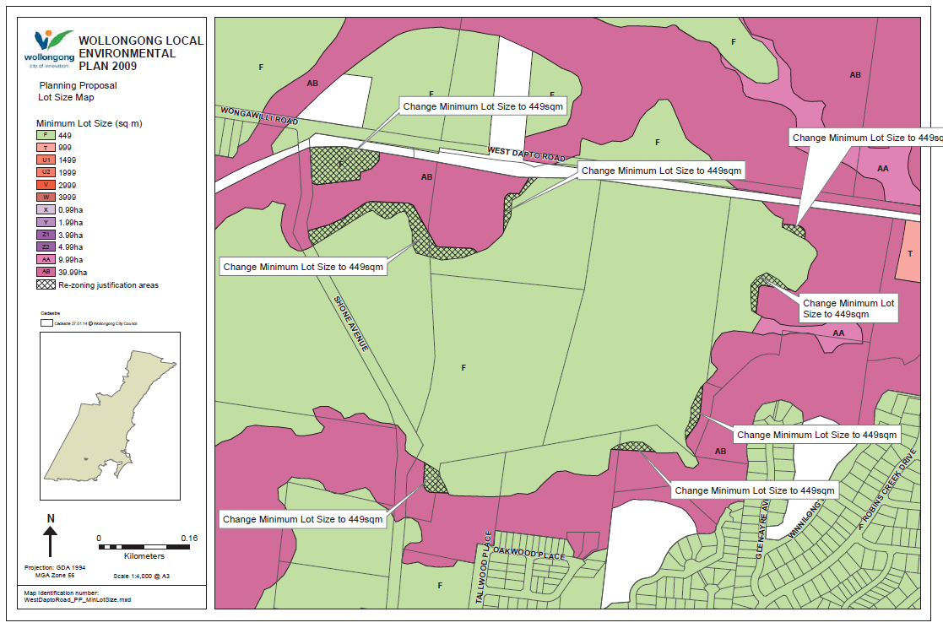

**Part 5: DETAILS OF COMMUNITY CONSULTATION TO BE UNDERTAKEN ON THE PLANNING PROPOSAL:**

|  |
| --- |
| Any Gateway Determination will confirm community consultation requirements. If the Planning Proposal is supported, the Proposal will be exhibited for a minimum period of *twenty-eight (28) days*, and include:   * Hard copies at Council’s Administration building and relevant Libraries; * Electronic copy on Council’s website; * Notification letters to surrounding and nearby property owners; and * Notification letters to relevant State agencies and other authorities nominated by the NSW Department of Planning and Environment including (but not limited to):   + Office of Environment & Heritage   + Office of Water   + RMS   + RFS   + Sydney Water |

**Part 6: PROJECT TIMELINE**

|  |
| --- |
| **A primary goal of the plan making process is to reduce the overall time taken to produce LEPs. This timeline tentatively sets out expected timelines for major steps in the process. These timeframes are subject to change and are to be used as a guide only. The Minister may consider taking action to finalise the LEP if timeframes approved for the completion of the Planning Proposal are significantly or unreasonably delayed.** |

|  |  |  |  |
| --- | --- | --- | --- |
| # | **Action** | **Estimated Timeframe** | **Responsibility** |
| 1 | Anticipated date of Gateway Determination | September 2015 (2 months) | Department of Planning and Environment |
| 2 | Anticipated completion of required technical studies | N/A | Consultants |
| 3 | Government agency consultation | October 2015 | Agencies |
| 4 | Public exhibition period | October 2015 | Council |
| 5 | Date of Public Hearing *(if applicable)* | N/A | Council |
| 6 | Consideration of submissions | October 2015 | Council |
| 7 | Assessment of proposal post-exhibition | November 2015 | Council |
| 8 | Report to Council | December 2015 | Council |
| 9 | Final maps and Planning Proposal prepared | January 2016 | Council |
| 10 | Submission to Department for finalisation of LEP | January 2016 | Council |
| *11* | *Anticipated date RPA will make the LEP* | January 2016 | Council (if under delegation) |
| 12 | Anticipated date Council will forward final Planning Proposal to DOP&I for notification | February 2016 | Council |
| 13 | Anticipated date LEP will be notified | February 2016 | *Parliamentary Counsel and DOP&I* |

**Table A - Checklist of State Environmental Planning Policies**

| **State Environmental Planning Policy** | | **Compliance** | **Comment** |
| --- | --- | --- | --- |
| **State policies** |  |  |  |
| SEPP No. 1 | Development Standard |  |  |
| SEPP No. 4 | Development Without Consent and miscellaneous Exempt and Complying Development |  | Clause 6 and parts 3 and 4 of SEPP were repealed by Wollongong LEP 2009 |
| SEPP No. 6 | Number of Storeys in a Building | Consistent | Planning Proposal does not propose controls for number of storeys |
| SEPP No. 14 | Coastal Wetlands | N/A |  |
| SEPP No. 15 | Rural Land Sharing Communities | Does not apply to Wollongong |  |
| SEPP No. 19 | Bushland in Urban Areas | Does not apply to Wollongong |  |
| SEPP No. 21 | Caravan Parks | N/A |  |
| SEPP No. 22 | Shops and Commercial Premises | N/A |  |
| SEPP No. 26 | Littoral Rainforests |  | No littoral rainforests identified by the policy in the Wollongong LGA |
| SEPP No. 29 | Western Sydney Recreational Area | Does not apply to Wollongong |  |
| SEPP No. 30 | Intensive Agriculture | N/A |  |
| SEPP No. 32 | Urban Consolidation (Redevelopment of Urban Land) | N/A |  |
| SEPP No. 33 | Hazardous and Offensive Development | N/A |  |
| SEPP No. 36 | Manufactured Home Estates | N/A |  |
| SEPP No. 39 | Spit Island Bird Habitat | Does not apply to Wollongong |  |
| SEPP No. 41 | Casino/Entertainment Complex | Does not apply to Wollongong |  |
| SEPP No. 44 | Koala Habitat Protection | N/A |  |
| SEPP No. 47 | Moore Park Showground | Does not apply to Wollongong |  |
| SEPP No. 50 | Canal Estate Development | N/A |  |
| SEPP No. 52 | Farm Dams, Drought Relief and Other Works | Does not apply to Wollongong |  |
| SEPP No. 55 | Remediation of Land | Consistent | Contamination issues have been considered as part of the original rezoning of West Dapto and will be further considered as part of development applications. |
| SEPP No. 56 | Sydney Harbour Foreshores and Tributaries | Does not apply to Wollongong |  |
| SEPP No. 59 | Central Western Sydney Economic and Employment Area | Does not apply to Wollongong |  |
| SEPP No. 60 | Exempt and Complying Development | Consistent | N/A |
| SEPP No. 62 | Sustainable Aquaculture | N/A |  |
| SEPP No. 64 | Advertising and Signage | Consistent | N/A |
| SEPP No. 65 | Design quality of residential flat development | Consistent | N/A |
| SEPP No. 70 | Affordable Housing (revised schemes) | Does not apply to Wollongong |  |
| SEPP No. 71 | Coastal Protection | N/A |  |
| SEPP | Housing for Seniors or People with a Disability 2004 | Consistent |  |
| SEPP | Building Sustainability Index: BASIX 2004 | Consistent |  |
| SEPP | Major Projects 2005 | N/A |  |
| SEPP | Development on Kurnell Peninsular 2005 | Does not apply to Wollongong |  |
| SEPP | Sydney Region Growth Centres 2006 | Does not apply to Wollongong |  |
| SEPP | Mining, Petroleum Production and Extractive Industries 2007 | Consistent | N/A |
| SEPP | Infrastructure 2007 | Consistent | N/A |
| SEPP | Temporary Structures 2007 | Consistent | N/A |
| SEPP | Kosciuszko National Park – Alpine Resorts 2007 | Does not apply to Wollongong |  |
| SEPP | Rural Lands 2008 | Does not apply to Wollongong |  |
| SEPP | Affordable Rental Housing 2009 | Consistent |  |
| SEPP | Western Sydney Employment Lands 2009 | Does not apply to Wollongong |  |
| SEPP | Exempt and Complying Development Codes 2008 | Consistent |  |
| SEPP | Western Sydney Parklands 2009 | Does not apply to Wollongong |  |
| **Deemed SEPPS( former Regional Plans)** |  |  |  |
|  |  |  |  |
| Illawarra REP 1 | Illawarra | Repealed within Wollongong |  |
| Illawarra REP 2 | Jamberoo | Does not apply to Wollongong |  |
| Greater Metropolitan REP No.2 | Georges River catchment | Does not apply to Wollongong |  |
|  |  |  |  |

**Table B - Checklist of Section 117 Ministerial Directions**

| **Ministerial Direction** | **Comment** |
| --- | --- |
| 1. **Employment and Resources** |  |
| 1.1 Business and Industrial Zones | N/A |
| 1.2 Rural Zones | N/A |
| 1.3 Mining, Petroleum Production and Extractive Industries | The land is identified for future urban release in the Illawarra Regional Strategy and is zoned as such. This amendment only affects the zone boundaries and does not fundamentally alter the land uses that are currently permitted. |
| 1.4 Oyster Aquaculture | N/A |
| 1.5 Rural Lands | N/A |
| 1. **Environment and Heritage** |  |
| 2.1 Environment Protection Zone | Consistent  Minor adjustments to the E3 zone boundaries are proposed under this amendment. The minor boundary adjustment involves land that is E3 being rezoned to R2. The changes have been justified through a Neighbourhood Plan and supporting documentation (including an updated flood study) which has been independently assessed and which Council has endorsed for public exhibition. |
| 2.2 Coastal Protection | N/A |
| 2.3 Heritage Conservation | N/A  No known sites are being impacted upon as a result of the planning proposal. |
| 2.4 Recreation Vehicle Areas | N/A |
| 1. **Housing, Infrastructure and Urban Development** |  |
| 3.1 Residential Zones | Consistent  The minor boundary adjustment involves land zoned E3 being rezoned to R2, to better reflect the land constraints and facilitate an improved outcome in the Neighbourhood Plan.  These adjustments reflect the proposed road layout identified in the Neighbourhood Plan and the flooding constraints. The proposal is considered consistent with this direction and objectives as the land will, as specified in the direction, be adequately serviced, provide flexibility in the type of housing that can be delivered and enable a better design through the minimisation of impacts on the environment. |
| 3.2 Caravan Parks and Manufactured Home Estates | N/A |
| 3.3 Home Occupations | Consistent |
| 3.4 Integrating Land Use and Transport | Consistent  The site is identified as part of the West Dapto Urban release Area. The area has been subject to extensive design work, aimed at promoting access to housing, jobs and services by walking (networks of paths), cycling (cycleway paths) and public transport (designed in road networks). The Neighbourhood Plan that this planning proposal facilitates contains provisions for all three transport methods. |
| 3.5 Development Near Licensed Aerodromes | N/A |
| 3.6 Shooting Ranges | N/A |
| 1. **Hazard and Risk** |  |
| 4.1 Acid Sulfate Soils | N/A |
| 4.2 Mine Subsidence and Unstable Land | N/A |
| 4.3 Flood Prone Land | Part of the precinct is identified as flood prone due to Robins Creek, which is part of the Mullet Creek catchment. Flood prone land is zoned E3 Environmental Management. The applicant has submitted a more recent and detailed flood study of the precinct (KFW 2014) as an update to Council’s Mullet Creek Flood Study (2009), Flood Risk Management Plan and Mullet Creek Flood Extension Study (2011). The updated flood study demonstrated that the peak velocity and depth flows associated with the 1% Annual Exceedance Probability (AEP) annual exceedance probability storm event are generally contained within the back of the riparian creek system. Proposed residential lots and detention basins will not be located in the 1 in 100 year extent areas and it is therefore considered that the proposal is consistent with the direction and objectives.  Note that Council has resolved that further work is required as part of the Gateway determination to demonstrate how any proposed cut and fill of flood affected land could be managed within the Neighbourhood Plan area. |
| 4.4 Planning for Bushfire Protection | The land is identified as being bush fire prone due to the proximity to the Robins Creek riparian corridor system. Appropriate asset protection zones have been established in the Neighbourhood Plan for residential development located adjacent Robins Creek riparian corridor; for dwellings located adjacent the third order stream which flows across the north western corner of the Neighbourhood Precinct; and for dwellings located adjacent the “forest” vegetation in the fourth order section of the Robins Creek (eastern stream). The design and construction of roads shall comply with the specifications of *Planning for Bushfire Protection 2006*..The RFS have been consulted in relation to the drafting of the Neighbourhood Plan and will be included in all further consultation. |
| 1. **Regional Planning** |  |
| 5.1 Implementation of Regional Strategies | Consistent – the proposal provides additional housing supply, housing choice and protection of environmental attributes. Consistent with the vision and land use strategy for West Dapto as a key urban growth area, contained in the Illawarra Regional Strategy.  The proposal facilitates a Neighbourhood Plan which is a pre-requisite to the lodgement of a development application for West Dapto. |
| 5.2 Sydney Drinking Water Catchments | N/A |
| 5.3 Farmland of State and Regional Significance on the NSW Far North Coast | Not applicable to Wollongong |
| 5.4 Commercial and Retail Development along the Pacific Highway, North Coast | Not applicable to Wollongong |
| 5.5 Development in the vicinity of Ellalong, Paxton and Millfield (Cessnock LGA) | Not applicable to Wollongong |
| 5.8 Second Sydney Airport: Badgerys Creek | Not applicable to Wollongong |
| 1. **Local Plan Making** |  |
| 6.1 Approval and Referral Requirements | N/A |
| 6.2 Reserving Land for Public Purposes | N/A |
| 6.3 Site Specific Provisions | N/A |
| 1. **Metropolitan Planning** |  |
| 7.1 Implementation of the Metropolitan Plan for Sydney 2036 | Not applicable |